**10. ReactJS-HOL**

1. Create the React App

|  |
| --- |
| npm create-react-app officespacerentalapp |

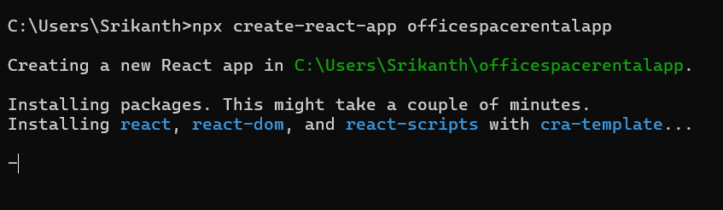

2.Modify App.js

|  |
| --- |
| App.js  import React from 'react';  function App() {    const heading = "Office Space";    const imgSrc = "https://t4.ftcdn.net/jpg/03/84/55/29/360_F_384552930_zPoe9zgmCF7qgt8fqSedcyJ6C6Ye3dFs.jpg";    const offices = [      { Name: "DBS", Rent: 80000, Address: "Chennai" },    ];    // Returns inline style object    const getRentStyle = (rent) => {      return {        color: rent <= 60000 ? 'red' : 'green',        fontWeight: 'bold',      };    };    return (      <div style={{ textAlign: 'center', fontFamily: 'Arial, sans-serif' }}>        <h1>{heading} , at Affordable Range</h1>        <img src={imgSrc} width="25%" height="25%" alt="Office Space" />        {offices.map((item, index) => (          <div key={index} style={{ marginTop: '20px' }}>            <h2>Name: {item.Name}</h2>            <h3 style={getRentStyle(item.Rent)}>Rent: Rs. {item.Rent}</h3>            <h3>Address: {item.Address}</h3>          </div>        ))}      </div>    );  }  export default App; |

**OUTPUT:**

**If rent is 80000**

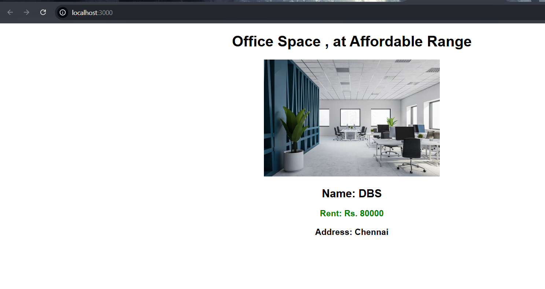

**If rent is 50000**

